SQL queries

[1] CREATE TABLE Employees (
EmployeeID VARCHAR(10) PRIMARY KEY,
EmployeeName VARCHAR(100) NOT NULL,
JobRole VARCHAR(100)
);
[2] CREATE TABLE TrainingRecords (
TrainingRecordID VARCHAR(10) PRIMARY KEY,
EmployeeID VARCHAR(10) NOT NULL,
Course VARCHAR(100) NOT NULL,
FOREIGN KEY (EmployeeID)
REFERENCES Employees(EmployeeID)
);

[3] INSERT INTO Employees (EmployeeID, EmployeeName, JobRole) VALUES
('E001', 'Alice Green', 'Data Analyst'),
('E002', 'Brian Jones', 'HR Officer'),
('E003', 'Chloe Smith', 'IT Support');

[4] INSERT INTO TrainingRecords (TrainingRecordID, EmployeeID, Course) VALUES
('T001', 'E001', 'SQL Fundamentals'),
('T002', 'E001', 'Data Protection (UK GDPR)'),
('T003', 'E003', 'Cyber Security Basics');

[a] SELECT * FROM Employees;
[b] SELECT * FROM TrainingRecords;

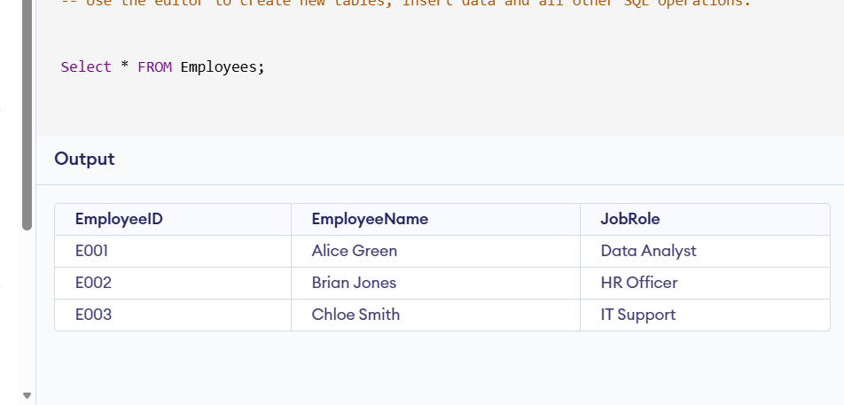

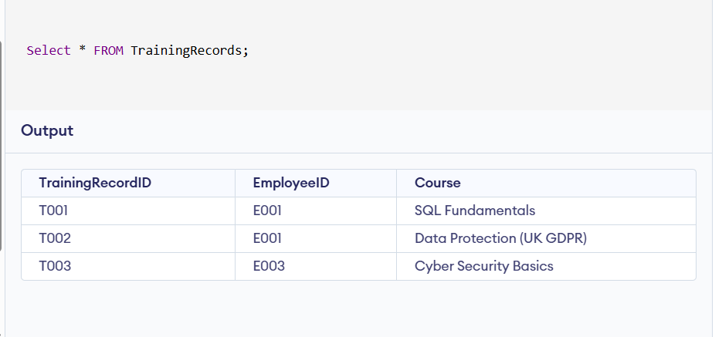

[5] SELECT
(SELECT EmployeeName FROM Employees WHERE EmployeeID = 'E001') AS EmployeeName,
TrainingRecordID,
EmployeeID,
Course
FROM TrainingRecords
WHERE EmployeeID = 'E001';
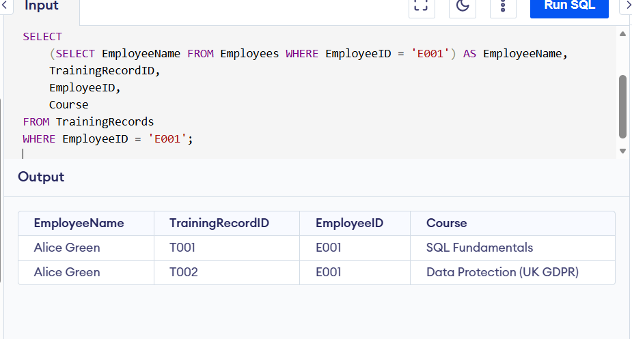

[6] SELECT TrainingRecordID, Course
FROM TrainingRecords
WHERE EmployeeID = 'E001';

